**Frontend of Return Item Header**

The Return Item Header at the frontend of the system is for accounting department for viewing purposes for the billing of the patient.

The picture below is the view of the Return Item Headers which is the user can search for the patient name and view of what are the items that have been return by the patient. It shows the reference table 1.1

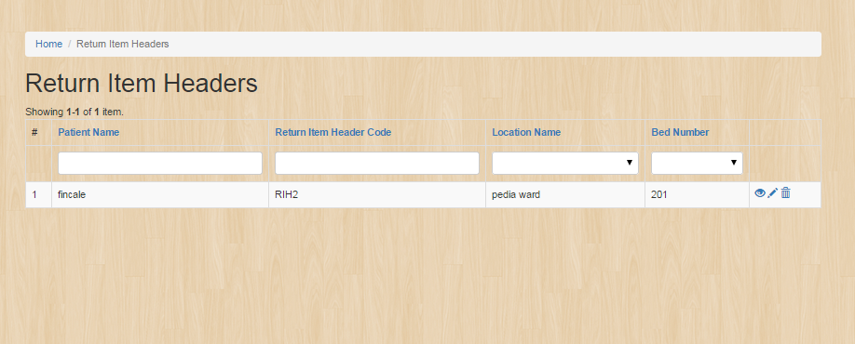

To view the details click the  , and the image below shows the details.

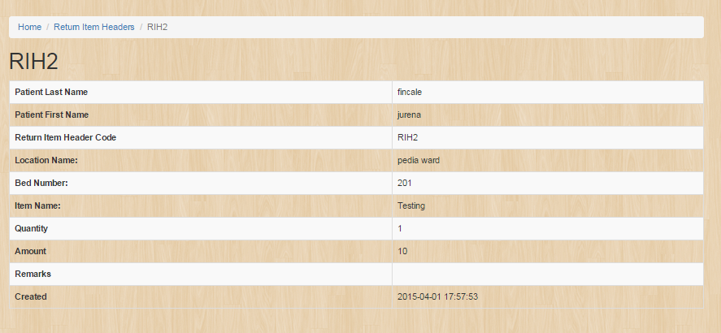

**Manage Employee Records**

Under the **User management** navigation bar, go to **Manage Employee Records** and the image below should be prompted which you can create, update and delete the item you will create .It shows the reference table 1.1.

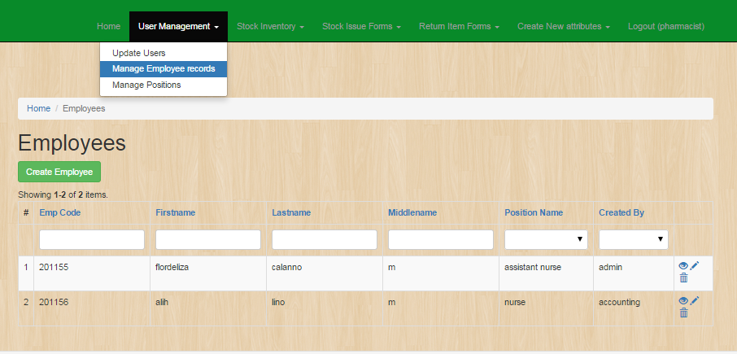

To create **Employee Record** click the button same as the image below:



And a new page like the image below would be open as you click the **create employee** button. Fill out the fields with appropriate data and click the button **create.**

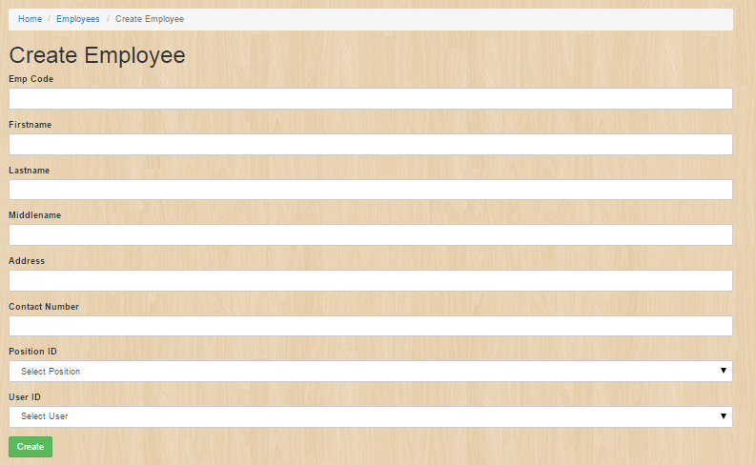

As you succesfully created employee record, an image below should be the result.

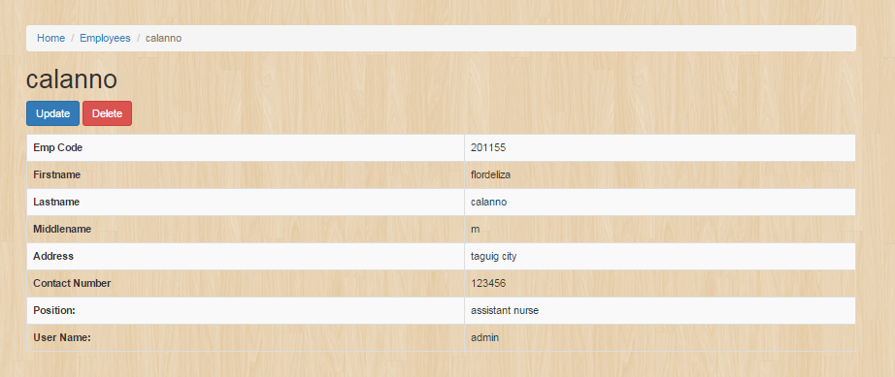

**Backend Return Item Details**

Under the **Return Item Forms** navigation bar, go to **Return Item Details** and the image below should be prompted which you can create, update and delete the item you will create .It shows the reference table 1.1.

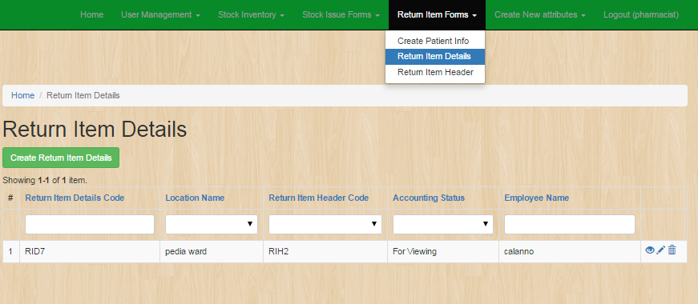

To create **Return Item Details** click the button same as the image below:



And a new page like the image below would be open as you click the **create Return Item Details** button. Fill out the fields with appropriate data and click the button **create.**

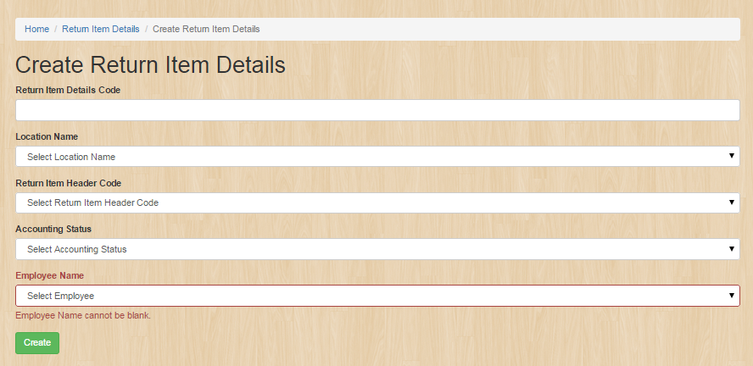

As you succesfully **created Return Item Details**, an image below should be the result.

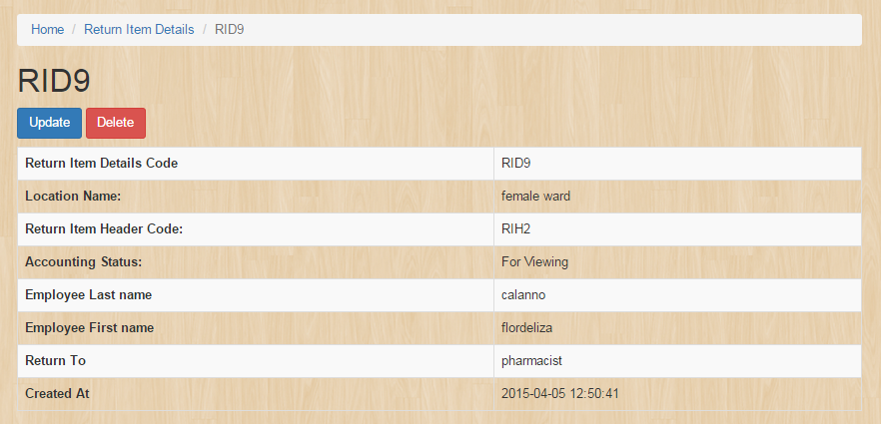

**Stock Inventory Record**

Under the **Stock Inventory** navigation bar, go to **Stock Inventory Record** and the image below should be prompted which you can create, update and delete the item you will create .It shows the reference table 1.1.

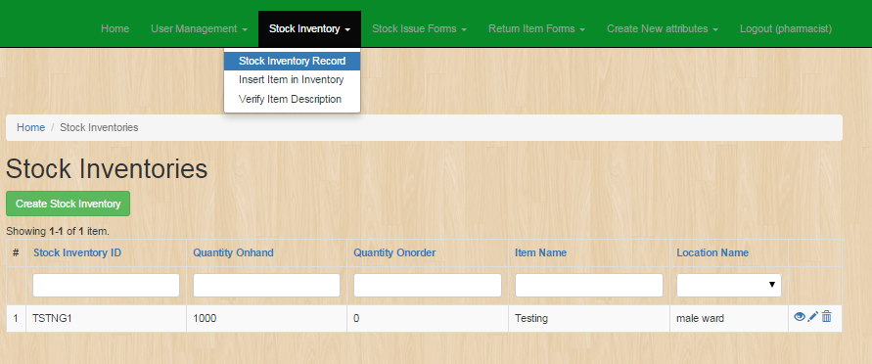

To create **Stocks Inventory** click the button same as the image below:



And a new page like the image below would be open as you click the **create Stock Inventory** button. Fill out the fields with appropriate data and click the button **create.**

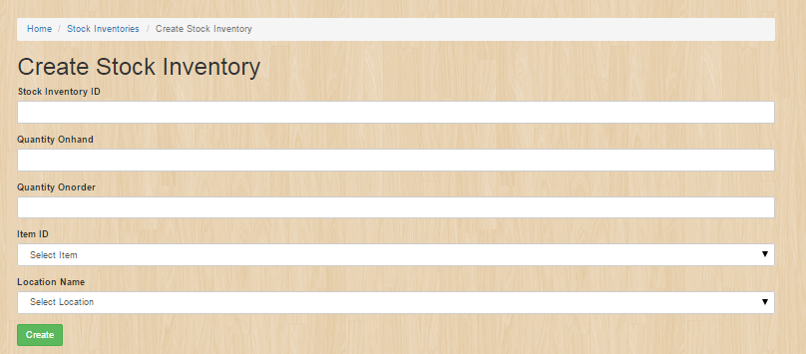

As you succesfully **created Stock Invetories**, an image below should be the result.

